**1. Describe the construction details and principle of operation of a D'Arsonval Galvanometer**

**Ans:** A D'Arsonval galvanometer is a type of instrument used to measure small electric currents. It operates based on the principle of electromagnetic induction and employs a moving coil. The instrument is named after the French physicist Arsène D'Arsonval, who developed this design in the late 19th century.

**\*\*Construction Details:**

**Coil:**

The heart of the D'Arsonval galvanometer is a rectangular coil made of a lightweight,insulated wire. This coil is typically wound on a light frame, often made of aluminum, and is suspended by a thin fiber or a torsion wire.

**Magnet:**

A permanent magnet or an electromagnet is positioned around the coil, providing a magnetic field perpendicular to the plane of the coil. The magnet's poles are situated on either side of the coil.

**Scale:**

A calibrated scale is placed in the magnetic field, usually behind the coil. This scale allows users to read the deflection of the coil and, consequently, the current being measured.

**Damping System:**

To prevent the coil from oscillating excessively and to ensure accurate readings, a damping system is incorporated. This system often includes an air damper, which provides resistance to the coil's movement.

**Spring Suspension:**

The coil is suspended by a spring or a torsion wire, allowing it to rotate freely within the magnetic field.

**\*\*Principle of Operation:**

A D'Arsonval galvanometer operates on the principle of electromagnetic induction. When a current flows through a suspended coil within a magnetic field, a torque is generated, causing the coil to deflect. The deflection is proportional to the current, allowing for the measurement of small electric currents. The instrument's spring or torsion suspension system provides a restoring torque for accurate readings.

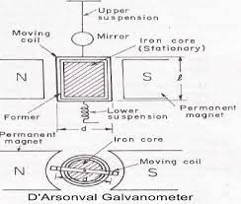

**\*\*Applications:**

**Ammeters and Voltmeters:**

D'Arsonval galvanometers serve as the basis for analog ammeters and voltmeters, providing a visual indication of current or voltage levels in electronic circuits.

**Galvanometer Bridge Circuits:**

D'Arsonval galvanometers are integrated into bridge circuits for comparing electrical resistances accurately.

**Telecommunication Testing:**

They are used in telecommunications for testing and troubleshooting electrical circuits, especially in scenarios where low current measurements are crucial.

**\*\*Advantages of D'Arsonval Galvanometer:**

**Sensitivity:**

D'Arsonval galvanometers are highly sensitive and can detect small currents, making them suitable for measuring weak electrical signals.

**Wide Range of Applications:**

These galvanometers can be adapted for various applications, including ammeters, voltmeters, and other measuring instruments.

**Low Power Consumption:**

Compared to some digital instruments, D'Arsonval galvanometers typically consume less power, making them suitable for battery-operated devices.

**\*\*Disadvantages of D'Arsonval Galvanometer:**

**Limited Dynamic Range:**

D'Arsonval galvanometers have a limited dynamic range, and their sensitivity diminishes for higher currents. This limitation can be addressed by using shunt resistors in ammeter applications.

**Susceptibility to External Magnetic Fields:**

External magnetic fields can influence the readings of a D'Arsonval galvanometer, requiring careful shielding in certain applications.

**Limited Frequency Response:**

D'Arsonval galvanometers may not respond well to rapidly changing currents or high-frequency signals due to the mechanical inertia of the moving parts.

**2. Three wattmeter method, two wattmeter method, one wattmeter method**

**Ans**: The three-wattmeter method, two-wattmeter method, and one-wattmeter method are techniques used in three-phase power measurement. These methods involve the use of wattmeters to measure power in a three-phase system. Let's briefly explore each method:

**\*\*Three-Wattmeter Method:**

In the three-wattmeter method, three separate wattmeters are connected to each phase of a threephase system. The power measured by each wattmeter is the power in each phase. The total power in the system is the sum of the readings from the three wattmeters.

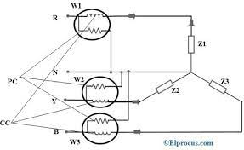

**\*\*Advantages:**

Accurate measurement of total power and power factor.

Suitable for both balanced and unbalanced loads.

**\*\*Connection:**

Each wattmeter is connected between one of the line conductors and the common point (neutral or ground) in a wye (star) connected system.

**\*\*Two-Wattmeter Method:**

The two-wattmeter method is commonly used for balanced loads. Two wattmeters are used, and their readings are combined to determine the total power in the three-phase system.

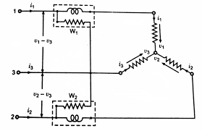

**\*\*Advantages:**

Suitable for balanced loads.

Simpler setup compared to the three-wattmeter method.

**\*\*Connection:**

In a wye (star) connected system, one wattmeter is connected between one line conductor and the common point (neutral). The other wattmeter is connected between another line conductor and the common point.

In a delta connected system, one wattmeter is connected between two line conductors, and the other is connected between another pair of line conductors.

**\*\*One-Wattmeter Method:**

The one-wattmeter method is used for measuring power in a single-phase circuit derived from one phase of a three-phase system. It is not suitable for measuring total three-phase power directly.

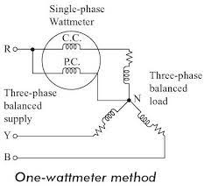

**\*\*Advantages:**

Simplest setup.

Suitable for single phase loads connected to one phase of a three phase system.

**\*\*Connection:**

The wattmeter is connected between one line conductor and the common point in a wye connected system.

In a delta connected system,the wattmeter is connected between one line conductor and another line conductor.

**\*\*Limitation:**

Cannot measure total three-phase power directly.

**3. Explain about Megger**

**Ans:** A megger, also known as an insulation resistance tester, is a portable instrument used to measure the electrical resistance of insulation materials. It is an essential tool for ensuring the safety and reliability of electrical installations.

## **\*\*Principle of Operation**

A megger generates a high DC voltage, typically ranging from 100 to 1,000 volts, and applies it to the insulation material being tested. The resistance of the insulation is then measured using an ohmmeter. The higher the resistance reading, the better the condition of the insulation.

## **\*\*Types of Meggers**

There are two main types of meggers:

**Portable meggers:**

These are handheld devices that are commonly used for testing electrical installations in buildings, factories, and other facilities.

**Laboratory meggers**:

These are more sophisticated instruments that are used for precise measurements in laboratories and manufacturing environments.

## **\*\*Applications of Meggers**

Meggers are used in a variety of applications, including:

* Testing the insulation of cables, wires, and busbars
* Assessing the condition of motors, generators, and transformers
* Verifying the integrity of underground cables
* Troubleshooting insulation faults and potential safety hazards

## **\*\*Safety Precautions**

When using a megger, it is important to follow proper safety precautions to avoid electrical shock. These precautions include:

* Ensuring that the circuit is de-energized before connecting the megger
* Wearing appropriate personal protective equipment (PPE), such as rubber gloves and safety glasses
* Keeping the megger away from wet or conductive materials
* Discharging the megger before disconnecting it from the circuit

**\*\*Importance of Megger Testing**

Regular megger testing is an essential part of electrical maintenance and safety programs. It helps to identify potential insulation problems before they can cause electrical failures or safety hazards. By conducting regular megger testing, electrical installations can be kept safe and reliable.

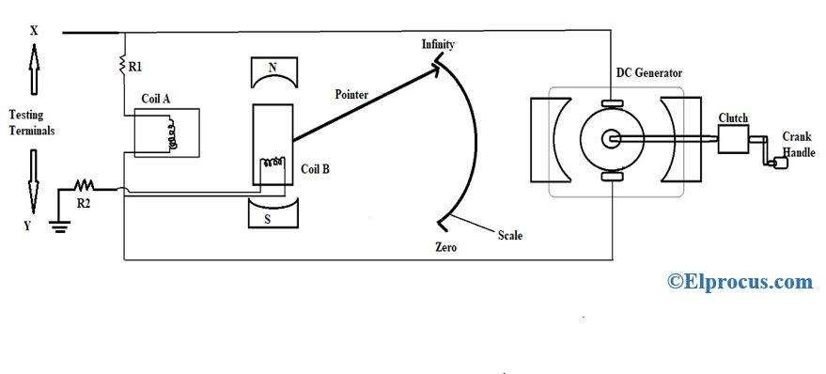

## Megger

**4. Explain the loading effect of ohmmeter**

**Ans:**

**\*\*Loading Effect of an Ohmmeter**

An ohmmeter is an instrument used to measure resistance. However, an ideal ohmmeter with zero internal resistance is impossible to achieve. This internal resistance of the ohmmeter introduces an "loading effect" on the circuit under measurement, which can affect the accuracy of the resistance reading.

**\*\*Here's how the loading effect works:**

* When the ohmmeter probes touch the component being measured, they essentially form a parallel circuit with the component's resistance.
* This parallel connection reduces the total resistance of the circuit, leading to a lower current flowing through the circuit.
* Consequently, the voltage drop across the component being measured also decreases.
* Since the ohmmeter calculates resistance based on the voltage drop and current flow, the presence of its internal resistance results in an underestimation of the actual resistance value.

**\*\*The magnitude of the loading effect depends on the following factors:**

* Internal resistance of the ohmmeter: Higher internal resistance leads to a more significant loading effect and a larger underestimation of the actual resistance.
* Resistance of the component being measured: The loading effect is more pronounced when measuring components with low resistance compared to those with high resistance.

**\*\*Here are some ways to minimize the loading effect of an ohmmeter:**

* Use an ohmmeter with a high internal resistance.
* Use a four-wire ohmmeter, which eliminates the effect of lead resistance.
* Connect the ohmmeter probes directly to the component's terminals, minimizing contact resistance.
* Check the manufacturer's specifications for the ohmmeter's internal resistance and its impact on accuracy at different resistance ranges. By understanding the loading effect and taking steps to minimize it, you can ensure more accurate resistance measurements with your ohmmeter.

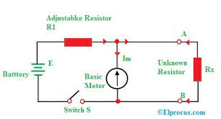

**5. Write a short note on AC bridges**

**Ans:** AC bridges are a type of electrical circuit used to measure unknown impedances by comparing them to known impedances. They are commonly used in electrical engineering and electronics to measure the inductance, capacitance, and resistance of components.

## 

## **\*\*Maxwell's bridge**

Maxwell's bridge, named after James Clerk Maxwell, is a type of AC bridge used to measure the inductance of a coil. It consists of four resistors and two inductors as shown in the figure below.

The unknown inductor (L1) is placed in one arm of the bridge, and the known inductor (L2) is placed in the other arm. The bridge is balanced by adjusting the values of the resistors (R1, R2, R3, and R4) until the current between the two inductors is zero. The unknown inductance can then be calculated from the values of the known inductor and the resistors.

The balance equation for Maxwell's bridge is:

L1/R1 = L2/R2

Maxwell's bridge is a versatile and accurate instrument for measuring inductance. It is used in a wide variety of applications, including:

* Measuring the inductance of coils and transformers
* Determining the quality factor of inductors
* Measuring the permeability of magnetic materials

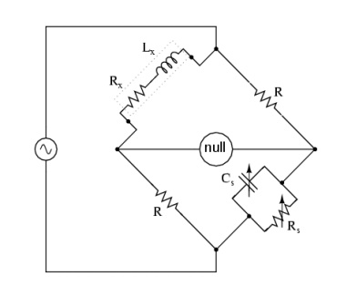

# 

# **Hay bridge:

The Hay bridge is a type of AC bridge used to measure the capacitance of a capacitor. It consists of four resistors and two capacitors as shown in the figure above. The unknown capacitor (C1) is placed in one arm of the bridge, and the known capacitor (C2) is placed in the other arm. The bridge is balanced by adjusting the values of the resistors (R1, R2, R3, and R4) until the current between the two capacitors is zero. The unknown capacitance can then be calculated from the values of the known capacitor and the resistors.

The balance equation for the Hay bridge is:

C1/R1 = C2/R2

The Hay bridge is a versatile and accurate instrument for measuring capacitance. It is used in a wide variety of applications, including:

* Measuring the capacitance of capacitors and cables
* Determining the permittivity of dielectric materials
* Measuring the frequency response of circuits

The Hay bridge is widely used in electronics and electrical engineering, as well as in other fields where accurate capacitance measurements are required.

# 

# 

# **Schering bridge:

The Schering bridge is a type of AC bridge used to measure the capacitance and conductance of a capacitor. It consists of four resistors and three capacitors as shown in the figure above. The unknown capacitor (C1) is placed in one arm of the bridge, and the known capacitors (C2 and C3) are placed in the other arms. The bridge is balanced by adjusting the values of the resistors (R1, R2, R3, and R4) until the current between the three capacitors is zero. The unknown capacitance and conductance can then be calculated from the values of the known capacitors and the resistors.

The balance equation for the Schering bridge is:

C1/R1 + G1 = (C2 + C3)/(R2 + R3 + R4)

The Schering bridge is a versatile and accurate instrument for measuring the capacitance and conductance of capacitors. It is used in a wide variety of applications, including:

* Measuring the capacitance and conductance of capacitors and cables
* Determining the dielectric loss of insulating materials
* Measuring the quality factor of capacitors

# 

# 

# 

# 

# 

# **Wien bridge:

The Wien bridge is a type of AC bridge used to generate a sine wave of a specific frequency. It consists of four resistors and two capacitors as shown in the figure above. The frequency of the sine wave is determined by the values of the resistors and capacitors. The Wien bridge is commonly used in audio oscillators and other electronic circuits that require a stable sine wave.

## **\*\*Principle of Operation:**

The Wien bridge is based on the principle of resonance. When the values of the resistors and capacitors are chosen correctly, the bridge will oscillate at a frequency that is determined by the following equation:

f = 1/(2πRC)

where:

* f is the frequency in hertz (Hz)
* R is the resistance in ohms (Ω)
* C is the capacitance in farads (F)

To generate a sine wave, the Wien bridge is connected to a positive feedback loop. The output of the bridge is fed back to the input, which sustains the oscillation. The amplitude of the sine wave can be controlled by adjusting the gain of the feedback loop.

## **\*\*Applications:**

The Wien bridge is a versatile and widely used circuit. It is commonly used in the following applications:

* Audio oscillators: The Wien bridge is a common component of audio oscillators, which are used to generate sine waves for a variety of purposes, such as testing audio equipment and generating music signals.
* Function generators: The Wien bridge can also be used in function generators, which are used to generate a variety of waveforms, including sine waves, square waves, and triangle waves.

Waveform filters: The Wien bridge can be used to filter out unwanted frequencies from a signal. For example, a Wien bridge can be used to filter out noise from an audio signal.

